Horizontal Line Segment
# Source: AI Source: Provided by: [Data Path: Persons Table -> ID Column: 1, Name_En Column: Motasem Essam] -> From: [ChatGPT] on [7/25/2026]
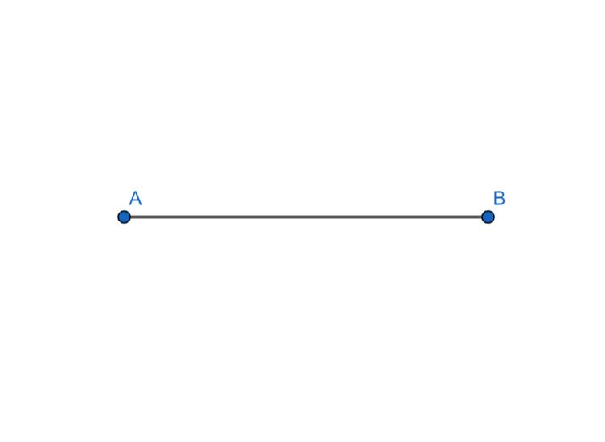
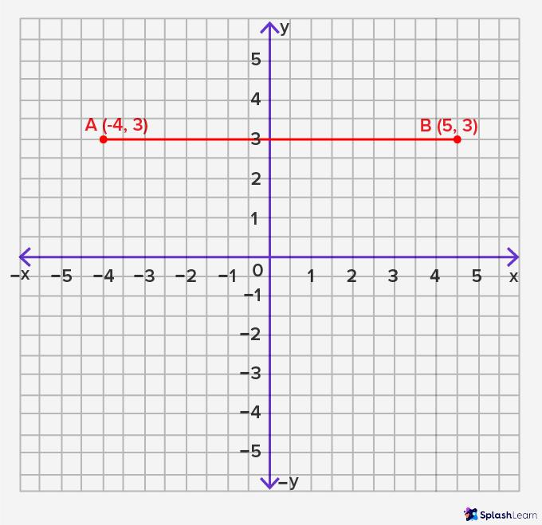
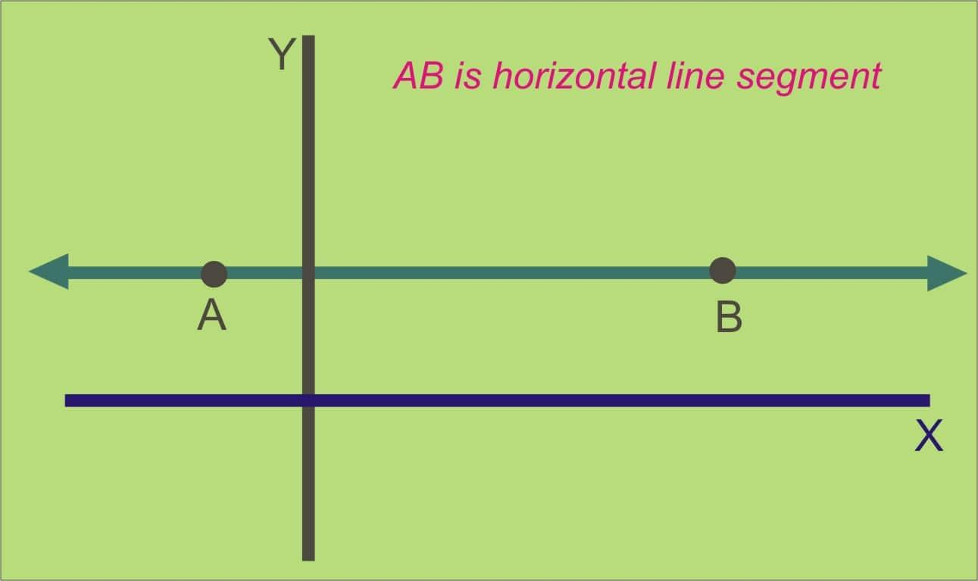
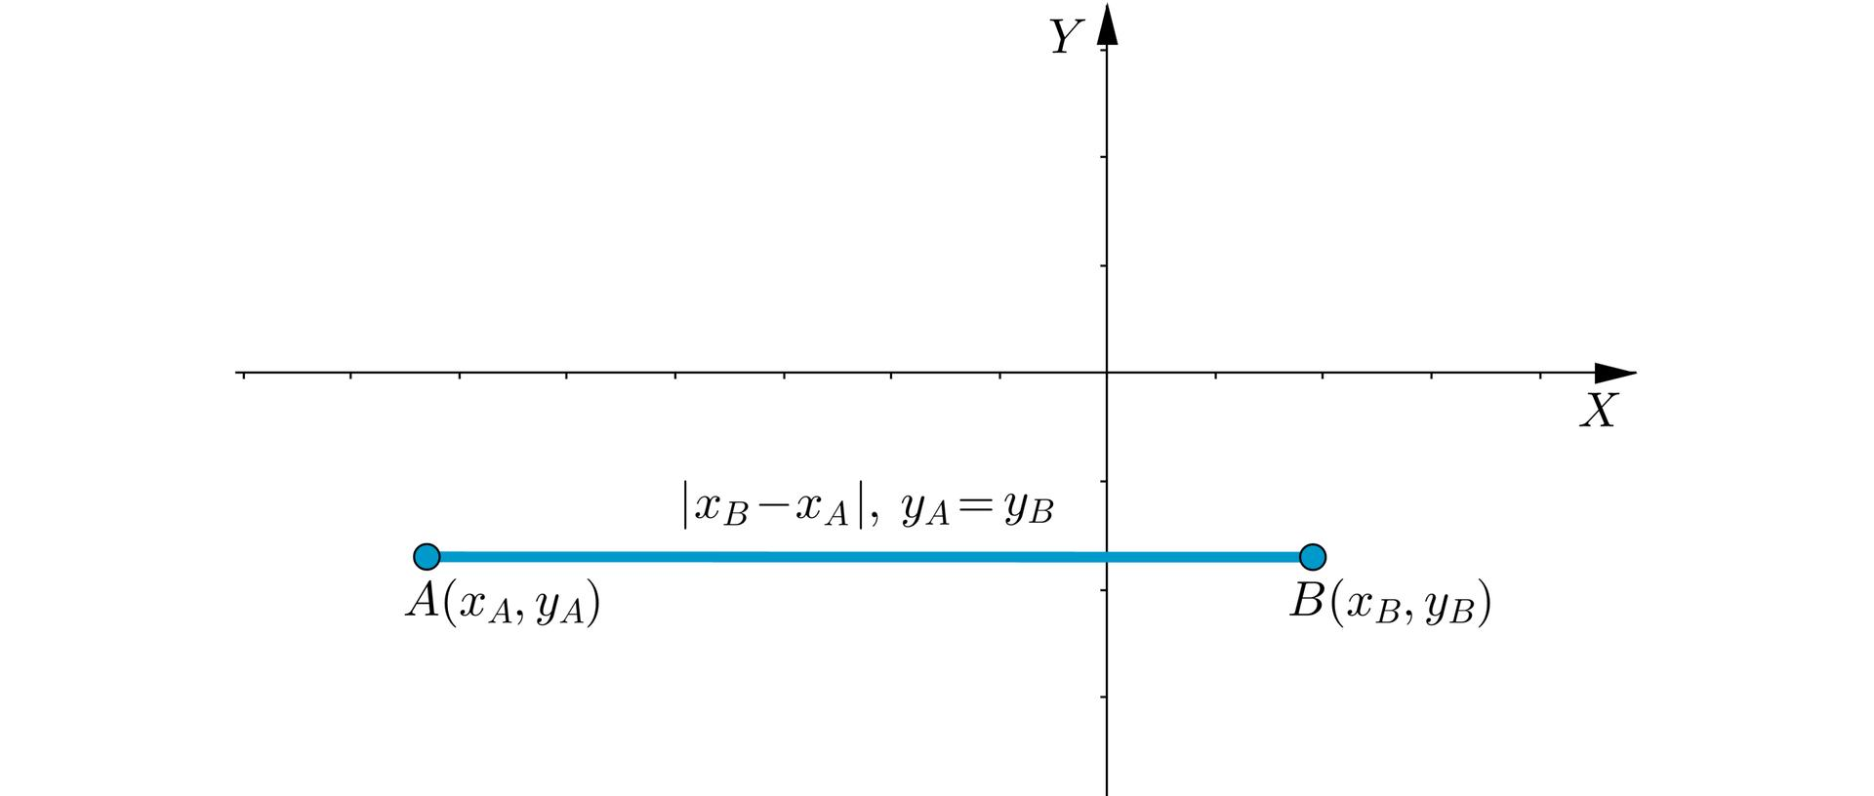
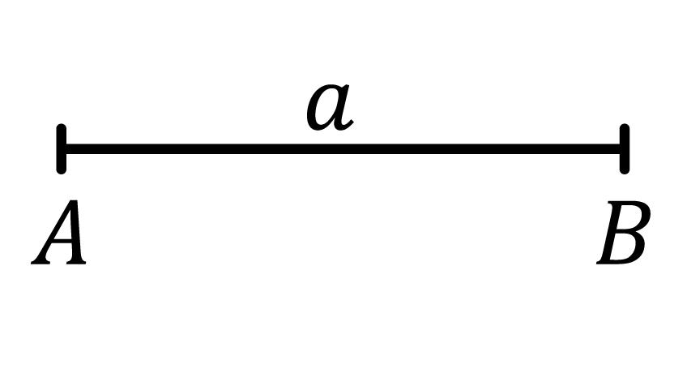

Definition
# Source: AI Source: Provided by: [Data Path: Persons Table -> ID Column: 1, Name_En Column: Motasem Essam] -> From: [ChatGPT] on [7/25/2026]
A Horizontal Line Segment is a finite straight line segment whose endpoints lie on the same horizontal level, meaning they have the same y-coordinate. It extends left to right (or right to left) but has two fixed endpoints, giving it a definite measurable length.
Unlike a horizontal line, a horizontal line segment does not extend infinitely.

Characteristics
# Source: AI Source: Provided by: [Data Path: Persons Table -> ID Column: 1, Name_En Column: Motasem Essam] -> From: [ChatGPT] on [7/25/2026]
A horizontal line segment:
- Has two endpoints.
- Has a finite length.
- Is parallel to the x-axis.
- Has a constant y-coordinate.
- Has a slope of 0.
- Can be measured.

Illustration
# Source: AI Source: Provided by: [Data Path: Persons Table -> ID Column: 1, Name_En Column: Motasem Essam] -> From: [ChatGPT] on [7/25/2026]
A ●──────────────● B
The segment begins at A and ends at B.

Coordinate Geometry
# Source: AI Source: Provided by: [Data Path: Persons Table -> ID Column: 1, Name_En Column: Motasem Essam] -> From: [ChatGPT] on [7/25/2026]
A horizontal line segment has endpoints such as:
$$A\left(x_{1} , y\right)$$
and
$$B\left(x_{2} , y\right)$$
where:
$$y_{1}=y_{2}$$

Example
$$A\left(2 , 5\right) \\ B\left(8 , 5\right)$$
Both endpoints have the same y-coordinate:
$$y=5$$
Therefore, the segment is horizontal.

Length
The length of a horizontal line segment is simply:
$$AB=∣x_{2}-x_{1}∣$$
since there is no vertical difference.

Example
If
$$A\left(2 , 5\right)$$
and
$$B\left(8 , 5\right)$$
then
$$AB=∣8-2∣=6$$

Slope
The slope of a horizontal line segment is:
$$m=0$$
because
$$Δy=0$$

Examples
# Source: AI Source: Provided by: [Data Path: Persons Table -> ID Column: 1, Name_En Column: Motasem Essam] -> From: [ChatGPT] on [7/25/2026]
Examples of horizontal line segments include:
- The top edge of a rectangle.
- A shelf.
- The edge of a table.
- A ruler placed flat.
- A horizontal beam.

Properties
# Source: AI Source: Provided by: [Data Path: Persons Table -> ID Column: 1, Name_En Column: Motasem Essam] -> From: [ChatGPT] on [7/25/2026]
A horizontal line segment:
- Has two endpoints.
- Has finite measurable length.
- Is parallel to the x-axis.
- Has slope equal to zero.
- All points on the segment have the same y-coordinate.

Applications
# Source: AI Source: Provided by: [Data Path: Persons Table -> ID Column: 1, Name_En Column: Motasem Essam] -> From: [ChatGPT] on [7/25/2026]
Horizontal line segments are used in:
- Plane Geometry
- Coordinate Geometry
- Engineering
- Architecture
- Construction
- CAD (Computer-Aided Design)
- Technical Drawing
- Computer Graphics
- Surveying
- Robotics

Advantages
# Source: AI Source: Provided by: [Data Path: Persons Table -> ID Column: 1, Name_En Column: Motasem Essam] -> From: [ChatGPT] on [7/25/2026]
Studying horizontal line segments helps to:
- Measure horizontal distances.
- Construct geometric figures.
- Analyze coordinate geometry.
- Create engineering drawings.
- Model level structural elements.

Limitations
# Source: AI Source: Provided by: [Data Path: Persons Table -> ID Column: 1, Name_En Column: Motasem Essam] -> From: [ChatGPT] on [7/25/2026]
A horizontal line segment:
- Has finite length.
- Exists only between its endpoints.
- Represents only one orientation.

Comparison with Related Objects
# Source: AI Source: Provided by: [Data Path: Persons Table -> ID Column: 1, Name_En Column: Motasem Essam] -> From: [ChatGPT] on [7/25/2026]
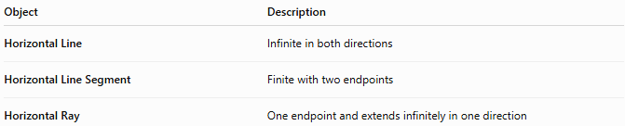
Object | Description
Horizontal Line | Infinite in both directions
Horizontal Line Segment | Finite with two endpoints
Horizontal Ray | One endpoint and extends infinitely in one direction

Key Points
# Source: AI Source: Provided by: [Data Path: Persons Table -> ID Column: 1, Name_En Column: Motasem Essam] -> From: [ChatGPT] on [7/25/2026]
- A Horizontal Line Segment is a finite portion of a horizontal line.
- It has two endpoints.
- All points have the same y-coordinate.
- Its slope is:
$$m=0$$
- Its length is:
$$AB=∣x_{2}-x_{1}∣$$
- Horizontal line segments are widely used in geometry, engineering, architecture, construction, CAD, surveying, and computer graphics.

Conclusion
# Source: AI Source: Provided by: [Data Path: Persons Table -> ID Column: 1, Name_En Column: Motasem Essam] -> From: [ChatGPT] on [7/25/2026]
A Horizontal Line Segment is a finite straight segment whose endpoints share the same vertical coordinate, making it parallel to the x-axis with a slope of zero. Unlike a horizontal line, it has a definite measurable length bounded by two endpoints. Horizontal line segments are fundamental in plane geometry, coordinate geometry, engineering, architecture, construction, surveying, CAD, technical drawing, robotics, and computer graphics, where they are used to represent level edges, horizontal distances, and structural components.

